PS labsheet 05

IT24100059

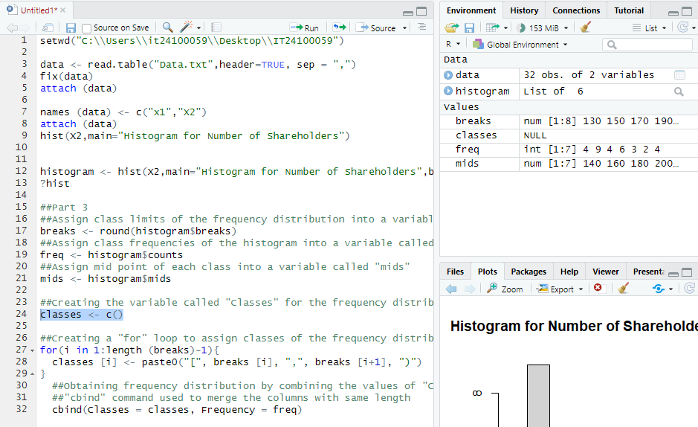

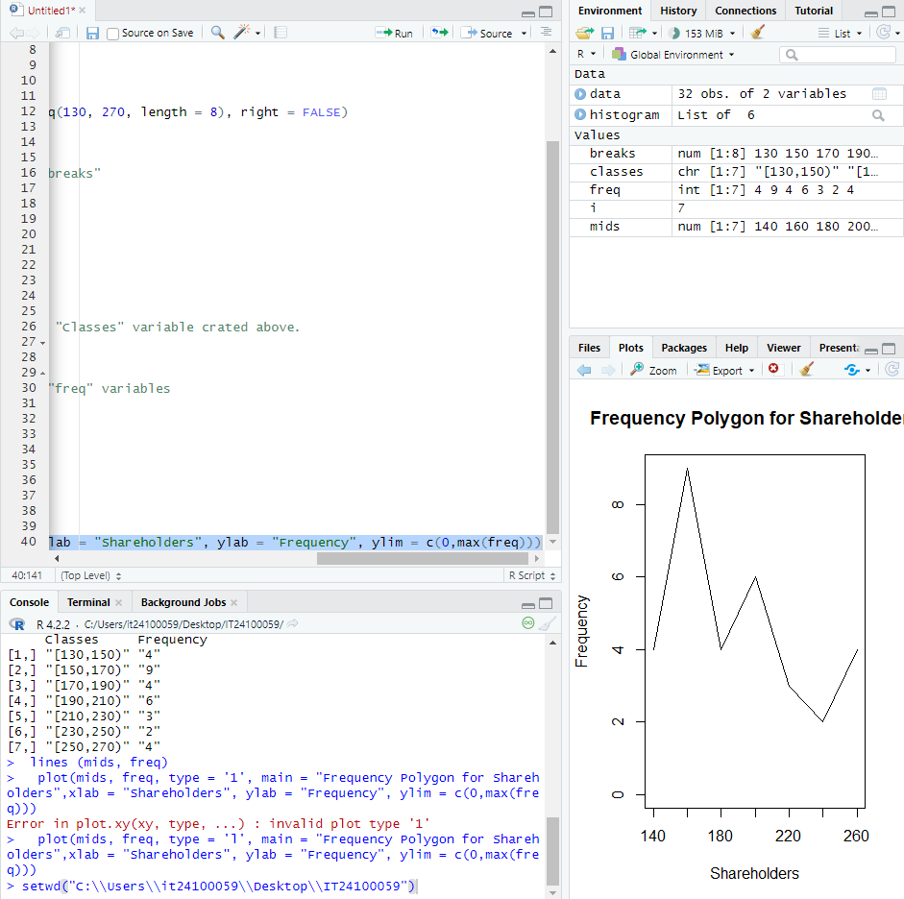

Exercise

#3.The distribution of delivery times is roughly symmetric with a slight right skew. Most deliveries take between 35 and 55 minutes

